Worksheet 2.2

Student Name: Sahil Kaundal UID: 21BCS8197

Branch: CSE (Lateral Entry) Section/Group:20BCS-807_B Semester: 4th Date of Performance: 18/03/2022

Subject Name: SE Lab Subject Code: 20CSP-255

Q1.

1. Aim/Overview of the practical:

Design a use case diagram for airport check-in and security screening.

Summary: Business use cases are Individual Check-In, Group Check-In (for groups of tourists), Security Screening, etc. - representing business functions or processes taking place in an airport and serving needs of passengers.

1. Task to be done/ Objective:



* The purpose of a use case diagram in UML is to demonstrate the different ways that a user might interact with a system.
* Create a professional diagram for nearly any use case using our UML diagram tool.
* Business use cases are Individual Check-In, Group Check-In (for groups of tourists), Security Screening, etc. - representing business functions or processes taking place in an airport and serving needs of passengers.

1. Requirement Analysis:

Software Requirement:

* Smart Draw
* Google Chrome

Hardware Requirement:

* Computer
* Windows 10
* Power Supply

1. Use Case Diagram (UML):

Use-case diagrams describe the high-level functions and scope of a system. These diagrams also identify the interactions between the system and its actors. The use cases and actors in use-case diagrams describe what the system does and how the actors use it, but not how the system operates internally.

Business use cases Baggage Check-in and Baggage Handling extend Check-In use cases, because passenger might have no luggage, so baggage check-in and handling are optional.

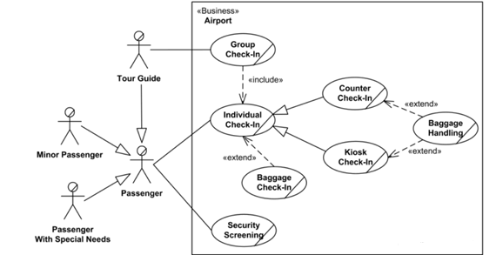

Q2.

1. Aim/Overview of the practical:

[**Bank ATM UML use case diagrams examples**](https://www.uml-diagrams.org/bank-atm-uml-use-case-diagram-example.html?context=uc-examples)

**Purpose**: Describe use cases that an automated teller machine (ATM) or the automatic banking machine (ABM) provides to the bank customers.

**Summary**: Customer uses a bank ATM to check balances of his/her bank accounts, deposit funds, withdraw cash and/or transfer funds (use cases). ATM Technician provides maintenance and repairs to the ATM.

1. Task to be done/ Objective:



* The purpose of a use case diagram in UML is to demonstrate the different ways that a user might interact with a system.
* Create a professional diagram for nearly any use case using our UML diagram tool.
* Describe use cases that an automated teller machine (ATM) or the automatic banking machine (ABM) provides to the bank customers.
* Customer uses a bank ATM to check balances of his/her bank accounts, deposit funds, withdraw cash and/or transfer funds (use cases). ATM Technician provides maintenance and repairs to the ATM.

1. Requirement Analysis:

Software Requirement:

* Smart Draw
* Google Chrome

Hardware Requirement:

* Computer
* Windows 10
* Power Supply

1. Use Case Diagram (UML):

Use-case diagrams describe the high-level functions and scope of a system. These diagrams also identify the interactions between the system and its actors. The use cases and actors in use-case diagrams describe what the system does and how the actors use it, but not how the system operates internally.

Customer uses a bank ATM to check balances of his/her bank accounts, deposit funds, withdraw cash and/or transfer funds (use cases). ATM Technician provides maintenance and repairs to the ATM.

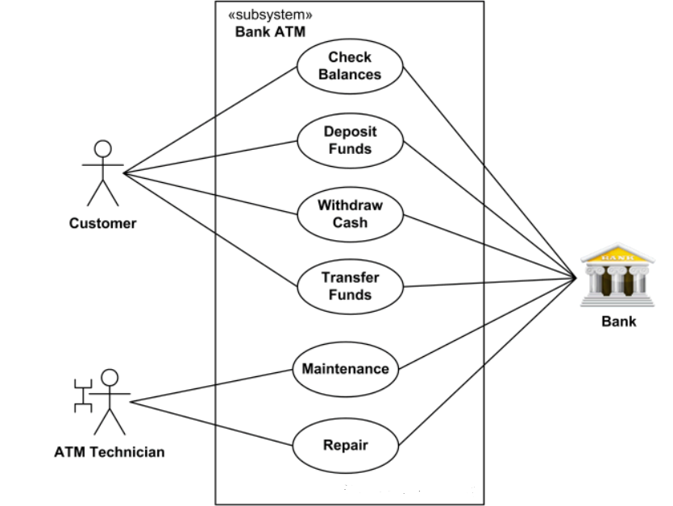

*On most bank ATMs, the customer is authenticated by inserting a plastic ATM card and entering a personal identification number (PIN).*Customer Authentication*use case is required for every ATM transaction so we show it as include relationship. Including this use case as well as transaction generalisation make the*ATM Transaction*an abstract use case.*

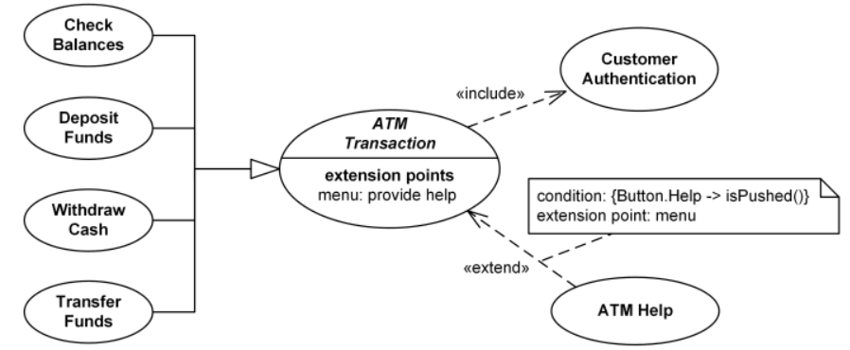

1. Result/Output/Writing Summary:

I have successfully done this practical.

Learning outcomes (What I have learnt):

1. Learned about use case diagram.
2. Learned about how UML diagram shows interaction between system and actors.

Evaluation Grid (To be created as per the SOP and Assessment guidelines by the faculty):



|  |  |  |  |
| --- | --- | --- | --- |
| Sr. No. | Parameters | Marks Obtained | Maximum Marks |
| 1. |  |  |  |
| 2. |  |  |  |
| 3. |  |  |  |
|  |  |  |  |